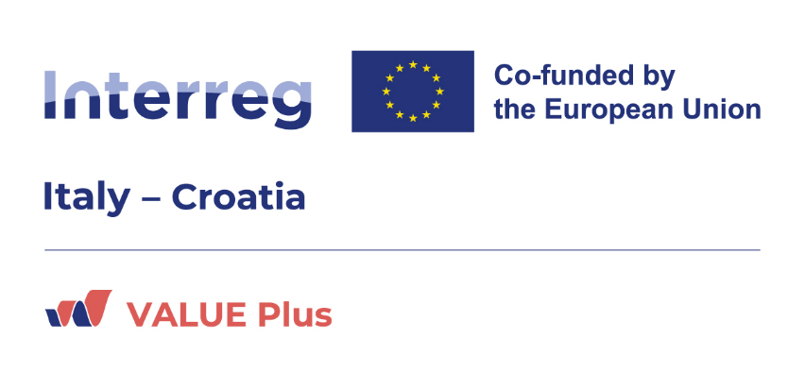

VALUE Plus, Value plus to cultural districts for the tourist enhancement of the cross-border area, is a European project funded by the Interreg Italy-Croatia 2021-2027 Programme, it aims to achieve the touristic valorization of cultural districts and the cross-border area.
Priority 4 - Culture and tourism for sustainable development
Specific objective 4.1 - Culture and sustainable tourism
Lead partner: Municipality of Ravenna
Partners:
- Po Delta Veneto Regional Park (IT)
- Emilia-Romagna Region (IT)
- Delta Institute Applied Ecology (IT)
- Town of Cres (CR)
- Municipality of Medulin (CR)
- Dubrovnik Development Agency DURA (CR)
- Municipality of Patù/Lecce (IT)
The primary objective of the VALUE Plus project is to promote and expand the districts for the valorization of tangible and intangible cultural heritage in the perspective of cross-border cooperation between Italy and Croatia. In addition, the project also aims to promote alternative and innovative forms of tourism, reduce the ecological footprint and improve the accessibility of places and destinations.
Project specific objectives
To develop a crossborder district strategy that will lead to the definition of an action plan for the development and promotion of the districts in the programme area
To improve the skills of current/future operators on the development of sustainable tourism offer
To increase awareness on the value of cultural resources of students and economic operators will improve the offer in the long term
To implement a coordinated and integrated management of the sustainable tourism offer of the districts, through the sharing of knowledge and the mapping on a single platform, allowing for the promotion and strengthening of the districts’ network
To enhance the accessibility of the cultural districts through the implementation of pilot actions, including the innovation of cultural hubs and the enrichment of the Adriatic-Ionian tourist routes

Below are the territories and topics that will be developed in the pilot actions:
- MAR – Art Museum of Ravenna (Municipality of Ravenna)
- Network of Veneto Cultural Hubs (Po Delta Veneto Regional Park)
- Accessibility at MUSA, Museo del Sale di Cervia (Emilia-Romagna Region)
- Enhancing the Open-Air Archaeological Park of Spina (Delta Institute Applied Ecology)
- Multimedia tourist guide in Cres (Town of Cres)
- Underwater cultural pathway in Medullin (Municipality of Medulin)
- Valorisation of the Dubrovnik Renaissance Waterworks (Dubrovnik Development Agency DURA)
- Museum Hub in Patù/Lecce (Comune di Patù)
Project main outputs
Integrated sustainable tourism offer
Pilot actions
Meta-District Strategy and Action Plan
Training activities
Start/end date: 30 months, from 01/02/2024 to 31/07/2026
RER budget: 244.360,00 €
Contact:
SETTORE ATTRATTIVITA', INTERNAZIONALIZZAZIONE, RICERCA
Area Ricerca - Progetti europei in ambito turistico, culturale e dei servizi. Reti europee in materia di turismo e cultura
Project website

